Supporting information:
Strategic Compositional Engineering in Quasi-2D Ruddlesden-Popper Perovskites to Decipher Deep Blue Emission
Ranadeep Raj Sumukam¹, Gundam Sandeep Kumar¹, Ramu Naidu Savu, and Banavoth Murali*
Solar Cells and Photonics Research Laboratory, School of Chemistry, University of Hyderabad, Prof. C R Rao Road, Hyderabad -500046, Telangana State, India.
*Email: murali.banavoth@uohyd.ac.in
EXPERIMENTAL SECTION
Materials and Methods: Lead Bromide (>98%) and Lead Chloride (>98%) were procured from TCI, Cesium Bromide (CsBr > 99.9%), Phenethylamine, Hydrochloric acid solution 37%, and Yttrium Chloride (anhydrous) were purchased from Sigma Aldrich, Dimethylsulfoxide (anhydrous 99.8%) purchased from Alfa Aesar. All these materials were used as received.
PEACl synthesis: For the synthesis of PEACl salt, equimolar phenethylamine and hydrochloric acid solution were reacted for 2 hours at 0º C under nitrogen conditions while stirring. After the completion of the reaction, PEACl (White powder) was recovered by rotary evaporation at 80 °C, followed by recrystallization using diethyl ether. Finally, the obtained recrystallized PEACl powder was dried in a vacuum oven for one day at room temperature.
Precursor solution of (PEA)₂(Cs)_{n-1}Pb_{n}(Br_{x}Cl_{1-x})_{3n+1}: Initially, individual solutions of CsPbBr₃, PbCl₂ (0.15 M), YCl₃ (0.25 M), and PEACl (1.00 M) were prepared in DMSO. Whereas precursor CsPbBr₃ was prepared by dissolving 1:1.5 molar ratios of PbBr₂ (293.6 mg) and CsBr (424.0 mg) in 6.4 ml DMSO, PbCl₂ solution was prepared by dissolving 333.8 mg PbCl₂ in 1.6 ml DMSO, YCl₃ solution was prepared by dissolving 49.0 mg YCl₃ in 1.0 ml DMSO, and PEACl solution was prepared by dissolving 316.0 mg PEACl in 2 ml DMSO. All the solutions were kept for stirring overnight at 70º C in the glove box. Finally, after 12 hours the temperature of the solutions was brought down to room temperature, and (PEA)₂(Cs)_{n-1}Pb_{n}(Br_{x}Cl_{1-x})_{3n+1} precursor was prepared by sequential mixing of CsPbBr₃ (0.8 ml) and PbCl₂ (0.2 ml) in such a way that molar ratios of the CsBr: PbBr₂: PbCl₂ equal to 2.5: 1.0: 1.5, then 20 µl of YCl₃ (2% of Cs), and a variable amount of PEACl with respect to Cs concentration (0.25 M) ( 0% (0.0 ml), 30% (0.075 ml), 60% (0.150 ml), 80% (0.200 m), 100% (0.250 ml), 120% (0.300 ml), and 140% (0.350 ml) ) was added for fixed composition of CsPbBr₃, PbCl₂, and YCl₃.
Q2DPe thin films fabrication: Glass substrates were used for the preparation of Q2DPe thin films. Firstly, the substrates were cleaned in the standard cleaning procedure. Then cleaned glass substrates were UV-ozone treated for 20 minutes before coating the perovskite. Thereafter, the substrates were transferred into the glove box for the spin coating. The final (PEA)₂(Cs)_{n-1}Pb_{n}(Br_{x}Cl_{1-x})_{3n+1} precursor solution (200 µl) was spin-coated on the substrate statically at 3000 rpm for 1 min, where antisolvent toluene (300 µl) was poured dynamically on perovskite film at the 20 second time point of that one minute, followed by annealing the thin film at 80º C for 10 minutes.
Q2DPe thin films characterization: UV-Vis Absorption spectra were recorded with JASCO V-750 Spectrophotometer equipped with an integrating sphere. Photoluminescence spectra (PLQY using an integrating sphere) were measured with JASCO FP-8500 Spectrofluorometer. Fluorescence intensity decay measurements were done using PicoQuant MicroTime 200 time-resolved confocal fluorescence microscope system (IRF=144 ps) where samples were excited by a pulsed picosecond diode laser (λ_{ex} = 405 nm) to obtain the average lifetime of the charge carriers. The structural and crystalline characterizations were determined by Powder XRD patterns and TEM obtained from Bruker D8 Advance X-ray diffractometer using Cu Kα radiation (of wavelength λ = 0.15406 nm) and JEM-F200 multi-purpose microscope (JOEL) with an accelerating voltage of 200 kV, respectively. The microstructural investigation was done by Atomic Force Microscopy (AC tapping mode) and Field-Emission Scanning Electron Microscope (electron beam accelerated to 3 kV was used) using MFP-3D Origin Asylum Instrument and Merlin compact model of Carl Zeiss, respectively.
Figure S1: PL spectra of 100% PEACl composition thin film at 372 nm and 393 nm excitation wavelength.

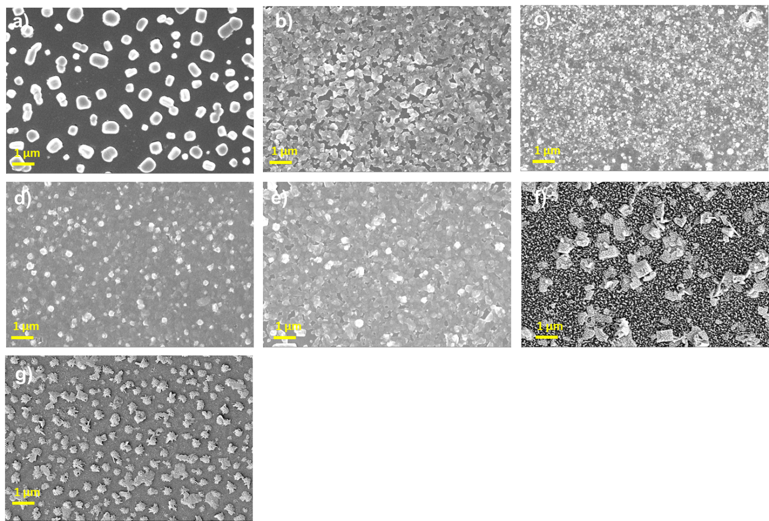
Figure S2:SEM micrograms showing the morphological changes in the thin films with the incorporation of PEACl into the 3D CsPbBr_{1.8}Cl_{1.2} system for a) 0% PEACl. b) 30% PEACl. c) 60% PEACl. d) 80% PEACl. e) 100% PEACl. f) 120% PEACl. g) 140% PEACl.

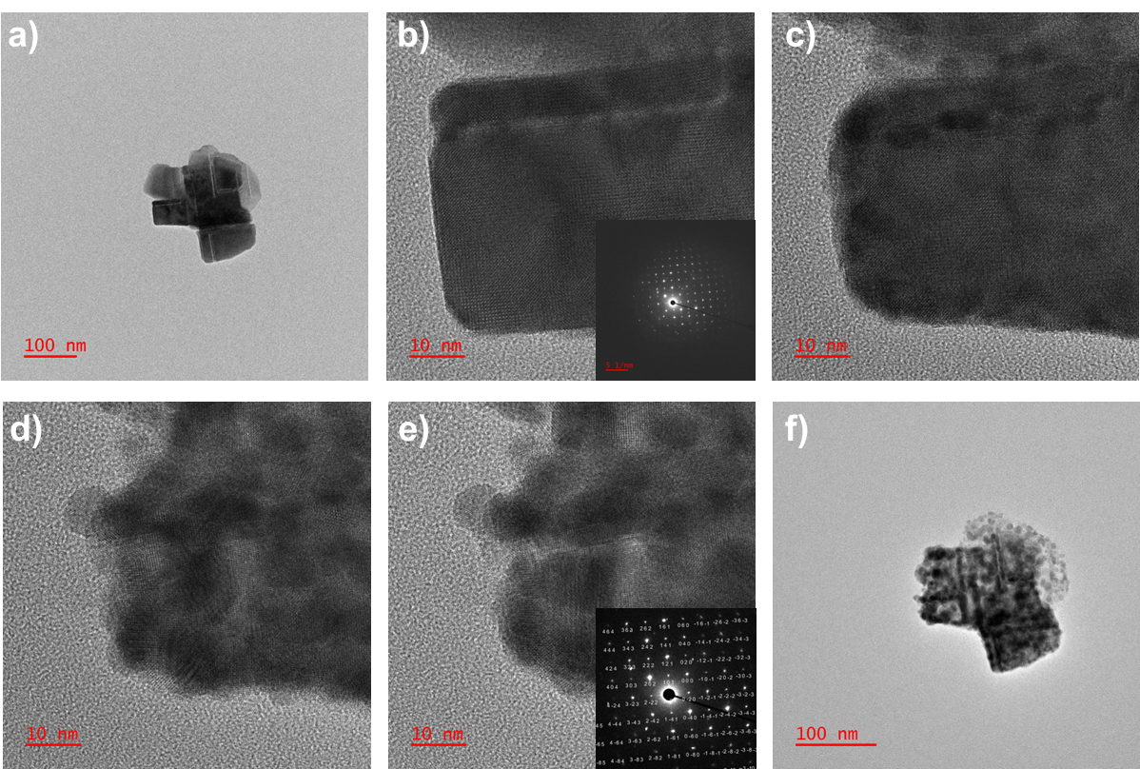 Figure S3: TEM images of the 100% PEACl sample in sequence (a-f) showing the formation of multiple domains in the thin films upon continuous irradiation of electrons.

